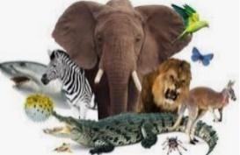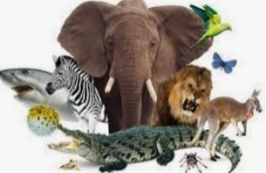

Summer Term 2025

Class 3

Enquiry Question: What makes us human?

(What is the difference between humans and animals?)

Identity

Influence

**Key concepts**

Individuality

Responsibility

**Curriculum – Discover**

During this project, we will explore how and why scientists classify animals into different groups. We will examine what makes humans special and what distinguishes us from the rest of the animal kingdom. We will learn about civilisations and how humans create them. We will compare ecosystems, biomes and climate around the world, focussing on the impact of humanity on climate change and looking at what we might do to make a difference in our lifetime.

**English:**

* Explanation text – How do bees make honey?
* Persuasive advert – Visit Ancient Egypt !
* Characterising speech – Egyptian Cinderella
* Non-chronological report – The human skeleton and muscular system
* Continued focus on developing our Reading Skills.
* Continued focus on spelling patterns, grammar and punctuation, following the National Curriculum.

**Class Novels:**

* Charlotte’s Web by E. B. White
* The Queen’s Nose by Dick King Smith

**Maths:**

**Y3:** Fractions, shape, measurement and statistics.

**Y4:** Fractions, shape, measurement and statistics.

Y3&4

Fluency in arithmetic

Times tables recall

* Narr

**Launch Week**

The children will begin to explore civilisations and imagine their own. They will begin to learn about biomes and create one in a shoebox. They will also learn about the different types of life in each biome and how living things survive.



**Animals including humans**

* identify that animals, including humans, need the right types and amount of nutrition, and that they cannot make their own food; they get nutrition from what they eat.
* identify that humans and some other animals have skeletons and muscles for support, protection, and movement.
* describe the simple functions of the basic parts of the digestive system in humans.
* identify the different types of teeth in humans and their simple functions.
* construct and interpret a variety of food chains, identifying producers, predators and prey.

**Living things and their habitats**

* recognise that living things can be grouped in a variety of ways.
* explore and use classification keys to help group, identify and name a variety of living things in their local and wider environment.

**Other curriculum areas:**

* **Art/DT:** Creating clay cartouches. Designing a dragon’s eye. Sculpture and structure. Textiles – creating Egyptian inspired collars.
* **Computing:** Sequencing in music. Connecting computers – inputs, processes and outputs.
* **Geography:** Where are the world’s biomes and ecosystems? What are the key human and physical characteristic of the countries in Europe?
* **History:** What is a civilisation? Were the ancient Egyptians successful?
* **Music:** Exploring Reggae music.
* **P.E:** Athletics – running increased distances. Net and wall games – directing the ball. Striking and fielding games – playing as a team.
* **RE:** What kind of world did Jesus want? How and why do people try to make the world a better place?
* **PSHE:** JIGSAW - Relationships and Changing Me.

**Important Diary Dates**

* Visit to the Lost Gardens of Heligan - TBC
* Forest school Sessions – Start 24th April. Final session – 5th June
* Class 3 Summercourt Camp – 21st-23rd May

This overview shows the intended learning, which may change due to the interests of the children.